Links

**Token** pk.eyJ1IjoieWFuY2hhb21jcCIsImEiOiJjazlxMDRqbzYwZWE1M3NydGF1NmQ4NzVsIn0.5QSCMwT1WAipIpX0Oo83Hg

**URLs：**

**Base map update**

**NAME: Basemap [bike station grading + updated low income]**

**Layer name: bike_station**

**Layer name: areas_stats**

mapbox://styles/yanchaomcp/cka0mokvc1afo1inqmkze8be4 **update [near bike or not]**

mapbox://styles/yanchaomcp/cka1p38l05ilv1ip8ttxje65i  **with int variables**

**layer name: cluster**

mapbox://styles/yanchaomcp/cka1u9hul1phg1img6utmld3n **with clusters**

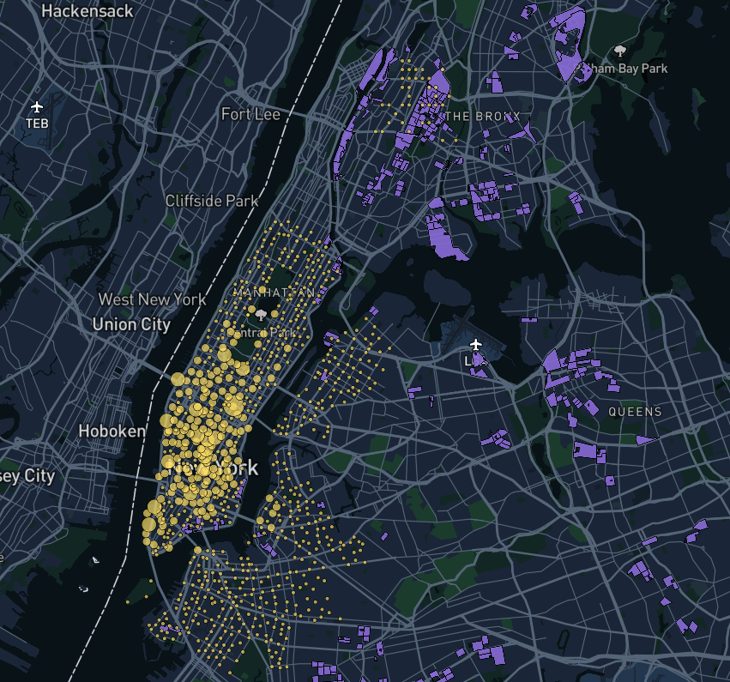

**Research area updates**

**NAME: area_stats [removed parks, other open spaces and recreational spaces]**

**Layer name: areas_stats**

mapbox://styles/yanchaomcp/cka0grc144b1q1imt3i0crre4

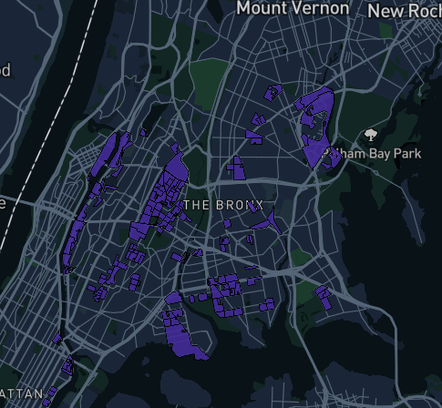

**BIKE STATION**

Name: bike

**Layer name： bike_station_2**

mapbox://styles/yanchaomcp/cka0jb1qq05iq1iqrr20p9h2d

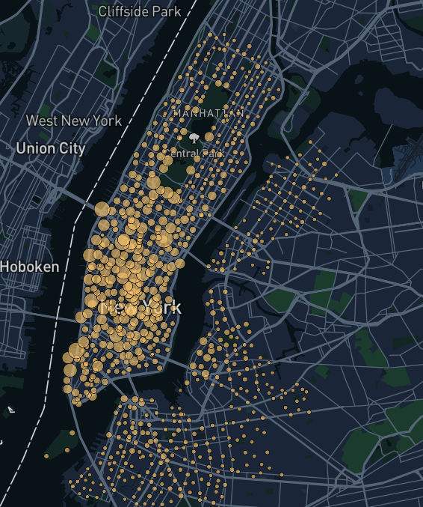

**All income**

**Name: all_income**

**Layer name: all_income**

mapbox://styles/yanchaomcp/cka0k5ddm0le61ipjmxasx32z

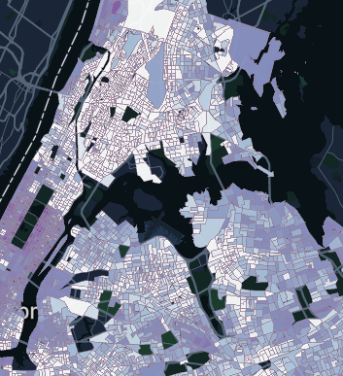

**Subway buffer**

**NAME: subway-copy**

**Layer name: subway-0-4-buffer-5ot2lk**

mapbox://styles/yanchaomcp/ck9qlfzk53nee1inrx7mjxese

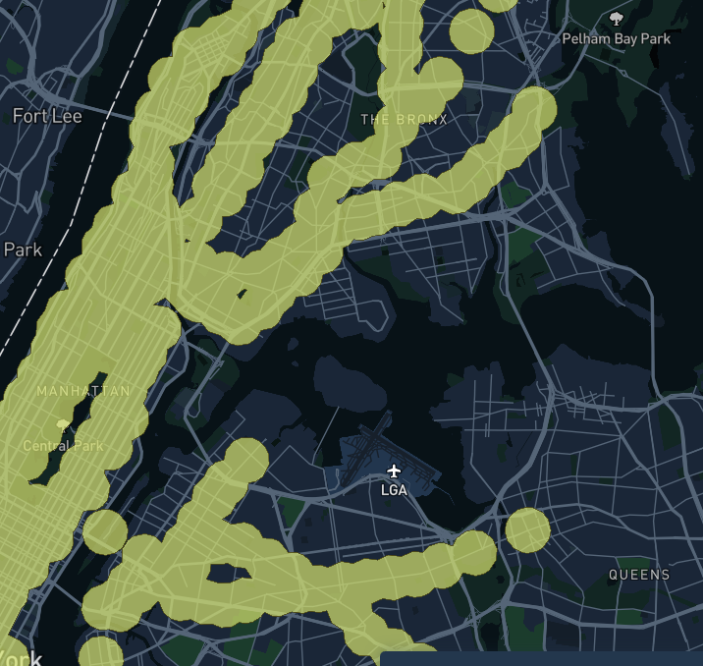

**Bus buffer**

**NAME: bus_buffer-copy**

**Layer name: bus-0-15mi-buffer-uni-3xoj98**

mapbox://styles/yanchaomcp/ck9qlugal3c2o1iomvgr0akaz

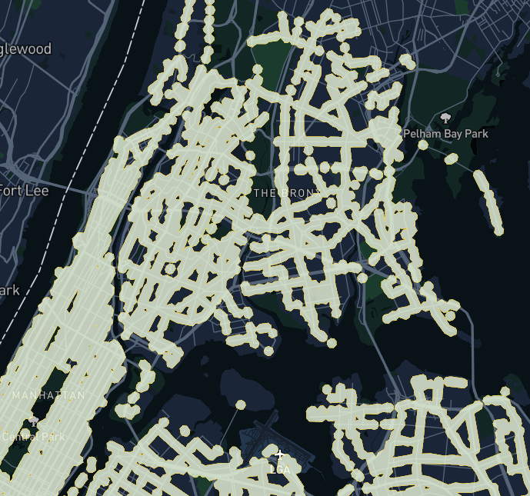

**Lack access (research areas)**

**NAME: lack access-copy**

**### layer name: lack-access-clgud9**

### mapbox://styles/yanchaomcp/ck9qlcep55e2l1iqfz4ptdfn8

**layer name: lack_access_area**

**mapbox://styles/yanchaomcp/ck9v3ygcv0oq21iqmmbbymk6j**

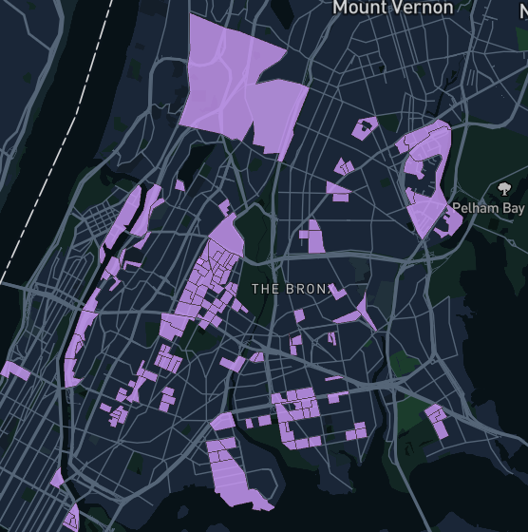

**Low income**

NAME: low_income

**Layer name: low-income-4ufciq**

mapbox://styles/yanchaomcp/ck9qh5wu03j8p1inr98tdm3tf

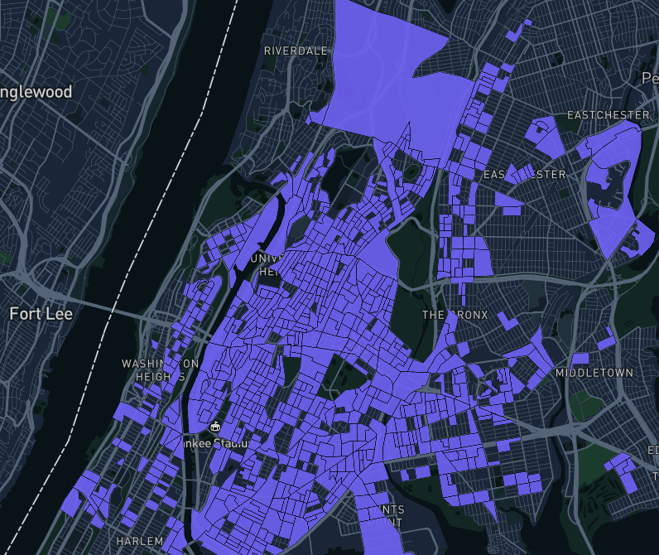

**All layers update six layers**

**Name: all_layers-copy**

mapbox://styles/yanchaomcp/cka0oauak0x0j1imy0ctnzann

bike_station

bus_buffer

subway_buffer

area_update

low_income

income

